ASSIGNMENT-7.3
(Error Debugging with AI: Systematic approaches to finding and fixing bugs)

HTNO:2303A51644
BATCH NO:28
Task 1: Fixing Syntax Errors
Scenario
You are reviewing a Python program where a basic function definition contains a syntax error.
Requirements
• Provide a Python function add(a, b) with a missing colon
• Use an AI tool to detect the syntax error
• Allow AI to correct the function definition
• Observe how AI explains the syntax issue
Expected Output
• Corrected function with proper syntax
• Syntax error resolved successfully
• AI-generated explanation of the fix

Prompt:
“Detect and fix the syntax error in the following Python function”
Buggy Code
def add(a, b)
return a + b
AI-Detected Issue
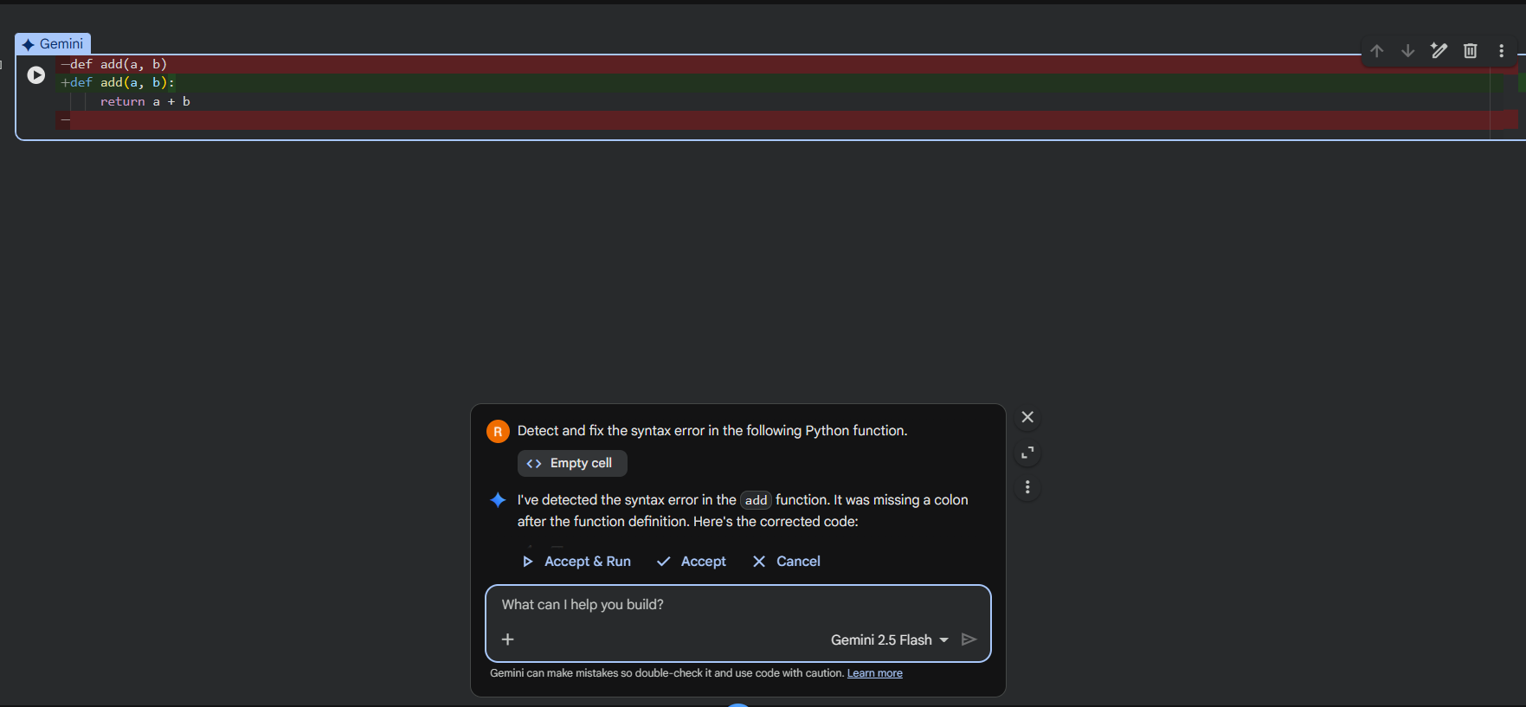
- Missing colon (:) at the end of the function definition.
Corrected code:

Explanation
- In Python, a colon is mandatory after function definitions.
- Without the colon, Python raises a SyntaxError.
- Adding the colon fixes the syntax issue and allows the function to execute properly.

Task 2: Debugging Logic Errors in Loops
Scenario
You are debugging a loop that runs infinitely due to a logical mistake.
Requirements
• Provide a loop with an increment or decrement error
• Use AI to identify the cause of infinite iteration
• Let AI fix the loop logic
• Analyze the corrected loop behavior
Expected Output
• Infinite loop issue resolved
• Correct increment/decrement logic applied
• AI explanation of the logic error

Prompt:
“Identify and fix the logical error causing an infinite loop.”
Buggy Code
def count_down(n):
while n >= 0:
print(n)
n += 1 # Should be n -= 1
AI-Detected Issue
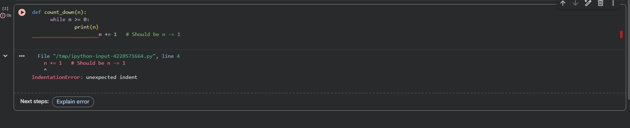
- IndentationError: unexpected indent
- The loop control variable n is incremented instead of decremented.
- Since the condition is n >= 0, increasing n makes the condition always true.
- This results in an infinite loop.

Corrected Code:
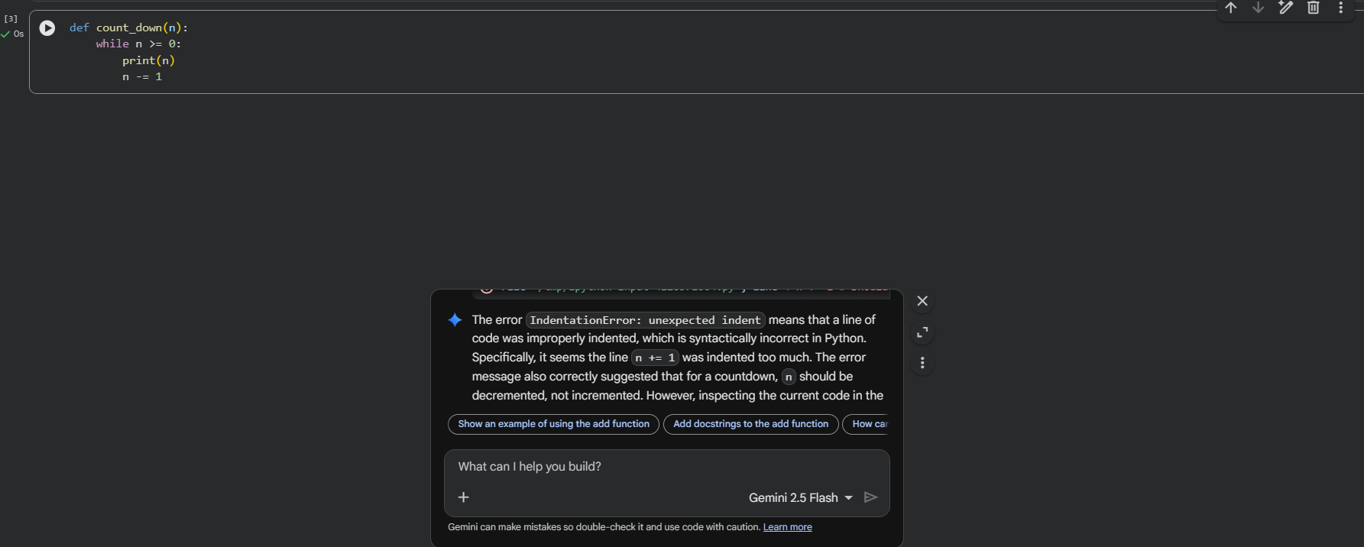
Explanation:
- The loop is intended to count down from n to 0.
- However, incrementing n prevents the loop from reaching the terminating condition.
- AI identified that decrementing n allows the loop condition to eventually become false.
- This correction stops the infinite execution.

Task 3: Handling Runtime Errors (Division by Zero)
Scenario
A Python function crashes during execution due to a division by zero error.
Requirements
• Provide a function that performs division without validation
• Use AI to identify the runtime error
• Let AI add try-except blocks for safe execution
• Review AI’s error-handling approach
Expected Output
• Function executes safely without crashing
• Division by zero handled using try-except
• Clear AI-generated explanation of runtime error handling
Prompt:
“Identify the runtime error and modify the code to prevent program crash”
Buggy Code
def divide(a, b):
return a / b
print(divide(10, 0))
AI-Detected Issue
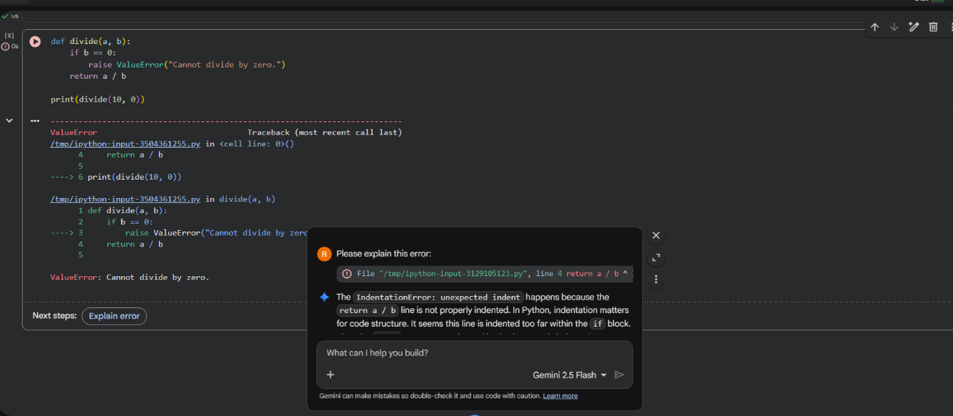
- Division by zero causes a ZeroDivisionError.
Corrected code:
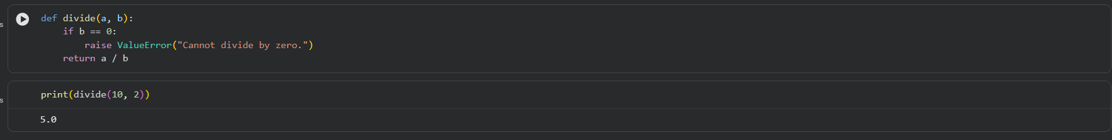
Explanation:
- AI identified that the runtime crash occurs due to division by zero.
- It added a validation check before performing division.
- Raising a ValueError prevents unsafe execution and clearly informs the user.
- This approach ensures safer and more predictable program behavior.

Task 4: Debugging Class Definition Errors
Scenario
You are given a faulty Python class where the constructor is incorrectly defined.
Requirements
• Provide a class definition with missing self-parameter
• Use AI to identify the issue in the __init__() method
• Allow AI to correct the class definition
• Understand why self is required
Expected Output
• Corrected __init__() method
• Proper use of self in class definition
• AI explanation of object-oriented error

Prompt:
“Identify the issue in the class constructor and correct it”
Buggy Code
class Student:
def __init__(name, roll):
name = name
roll = roll
AI-Detected Issue
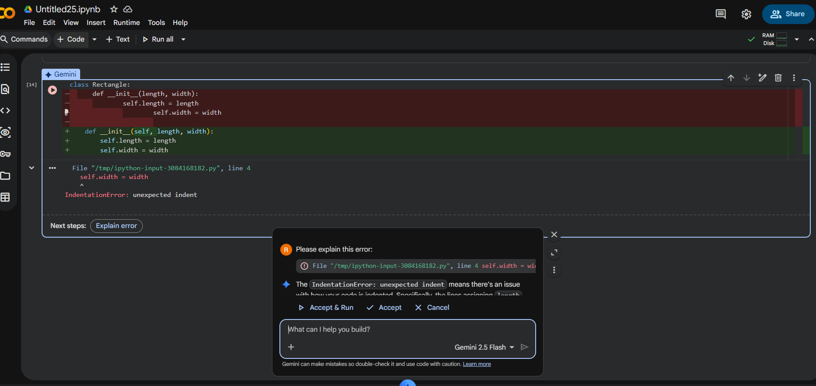
- Missing self parameter in the constructor.
- Instance variables are not properly assigned.
Corrected Code:
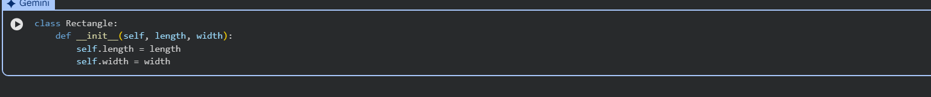
Explanation:
- self is mandatory in instance methods to access object data.
- AI identified that length and width must be associated with the object.
- Adding self allows proper initialization of instance variables.

Task 5: Resolving Index Errors in Lists
Scenario
A program crashes when accessing an invalid index in a list.
Requirements
• Provide code that accesses an out-of-range list index
• Use AI to identify the Index Error
• Let AI suggest safe access methods
• Apply bounds checking or exception handling
Expected Output
• Index error resolved
• Safe list access logic implemented
Prompt:
“Identify the index error and suggest a safe access method.”
Buggy Code
numbers = [1, 2, 3]
print(numbers[5])
AI-Detected Issue
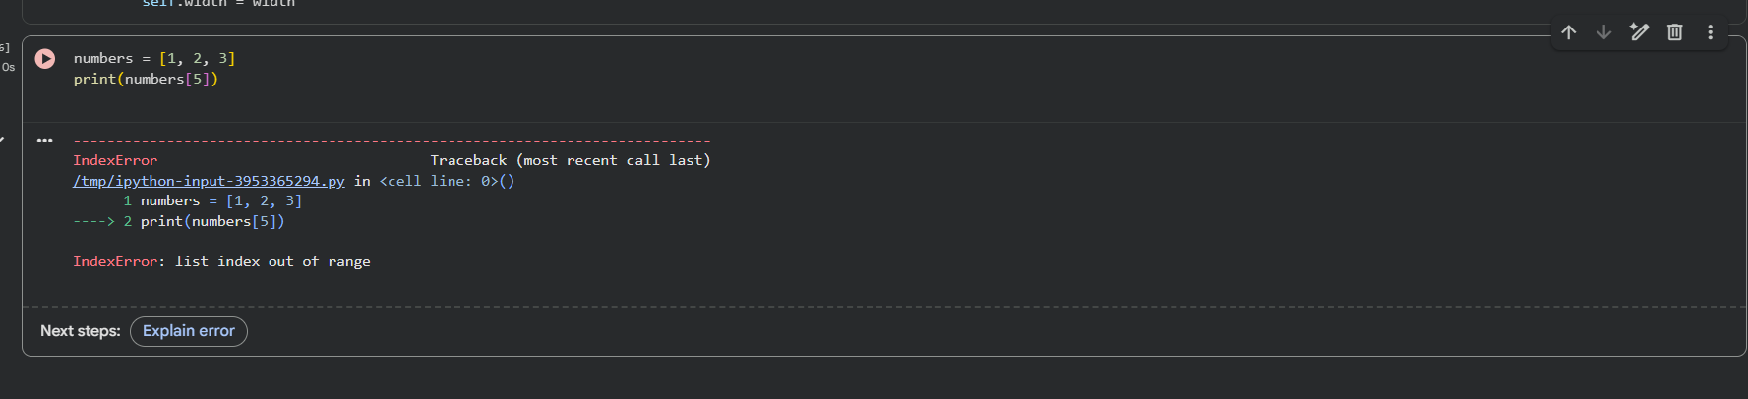
- Index 5 does not exist in the list.
- Causes IndexError.
Corrected code:
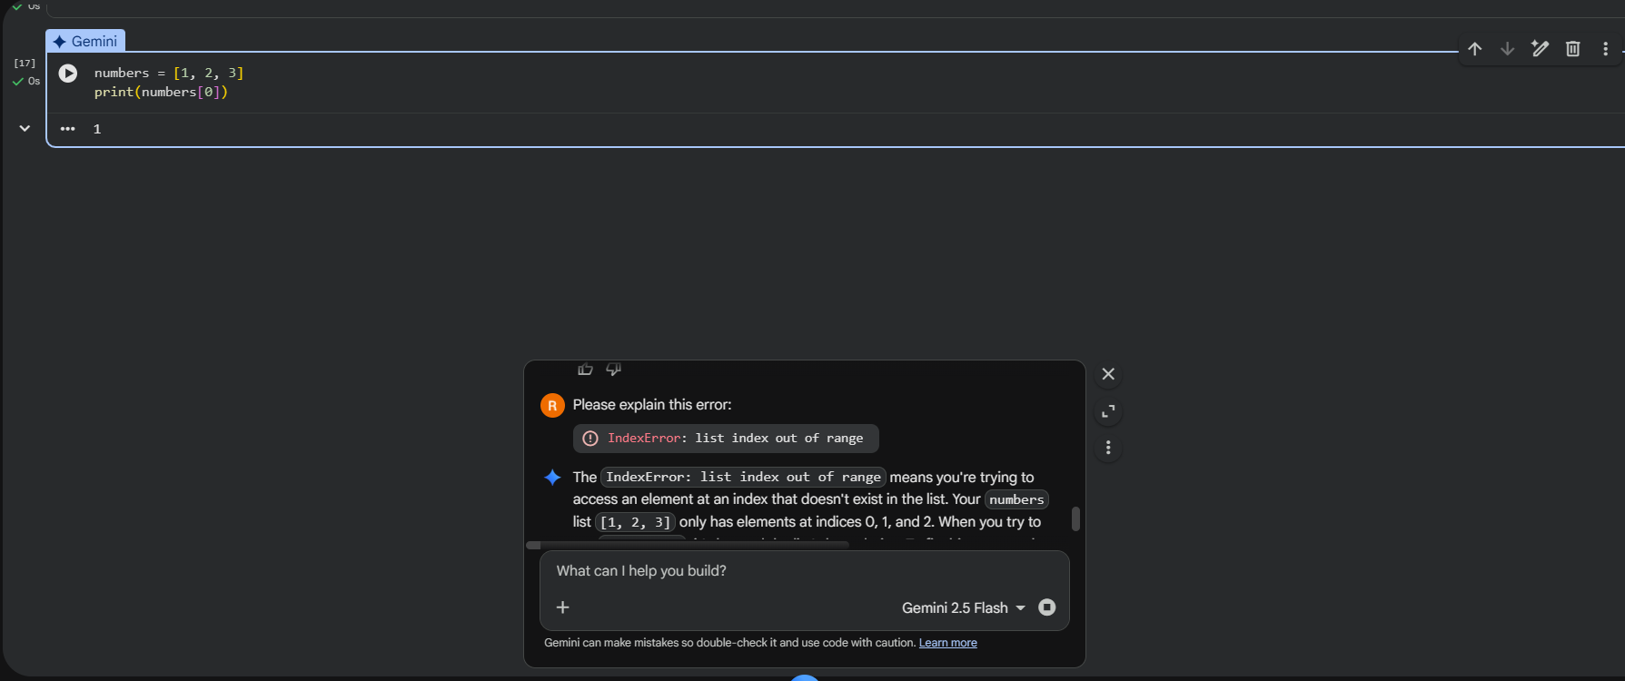
Explanation:
- List indices must be within the range of list length.
- Checking bounds prevents runtime errors.

